

NATIONAL INSTITUTE OF HAMIRPUR
HAMIRPUR (H.P.)

MATLAB FILE

NAME: MADHAW KUMAR BAGADIA
ROLL NO.: 23BEC058
COURSE NAME: DIGITAL COMMUNICATION LAB
COURSE CODE: EC-315
SUBMITTED TO: Dr. SANDEEP KUMAR SINGH
EXPERIMENT – 01

SAMPLING
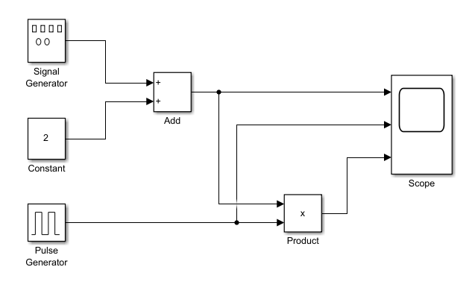

SIGNAL GENERATOR: CONSTANT:
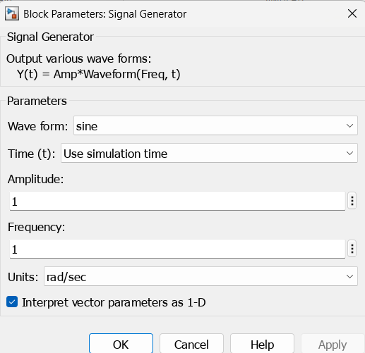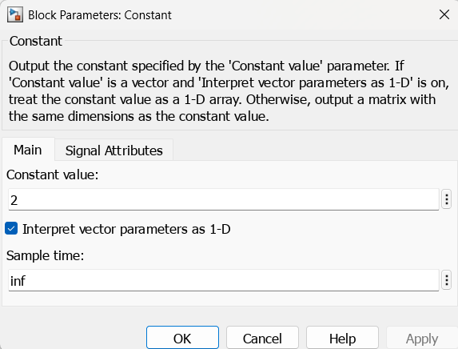

PULSE GENERATOR:
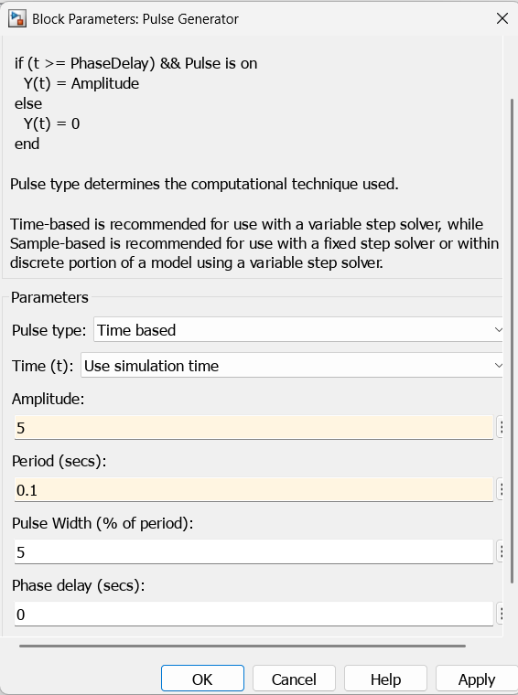

OUTPUT WAVEFORM:
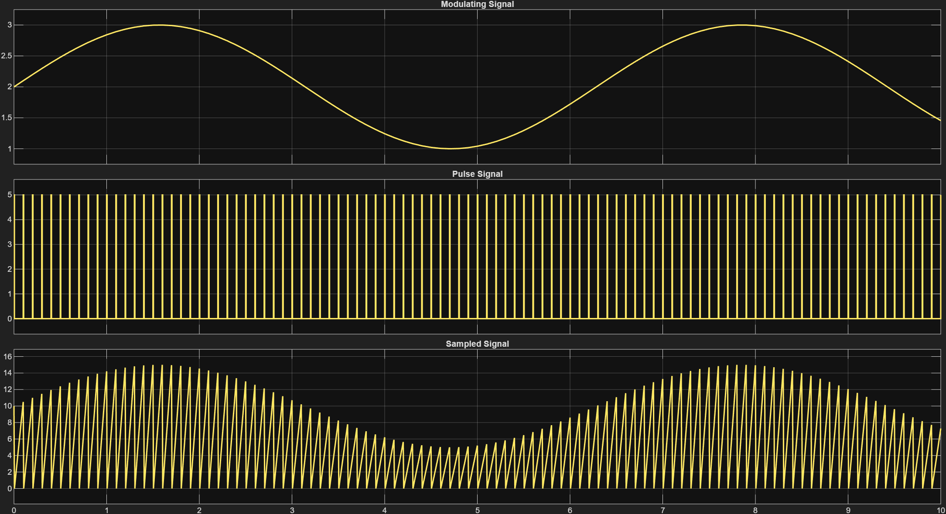

MATLAB CODE:
clc;
clear all;
close all;
f = 5; % Signal frequency
fs = 50; % Sampling frequency
t = 0:0.001:1; % Continuous time
ts = 0:1/fs:1; % Sampled time
x = sin(2*pi*f*t); % Continuous signal
y = sin(2*pi*f*ts); % Sampled signal
% Regenerate the original continuous signal using interpolation
x_regenerated = interp1(ts, y, t, "spline");
subplot(3,1,1);
plot(t, x);
title('Original Continuous Sine Wave');
xlabel('Time (s)');
ylabel('Amplitude');
subplot(3,1,2);
stem(ts, y, 'r'); % Use stem to clearly indicate discrete points
title('Sampled Sine Wave');
xlabel('Time (s)');
ylabel('Amplitude');
subplot(3,1,3);
plot(t, x_regenerated, 'g'); % Green dashed line for regenerated signal
title('Regenerated Continuous Sine Wave');
xlabel('Time (s)');
ylabel('Amplitude');

OUTPUT WAVEFORM:

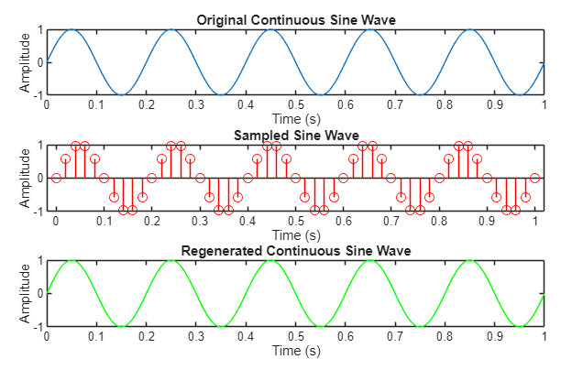
EXPERIMENT – 02

PULSE CODE MODULATION

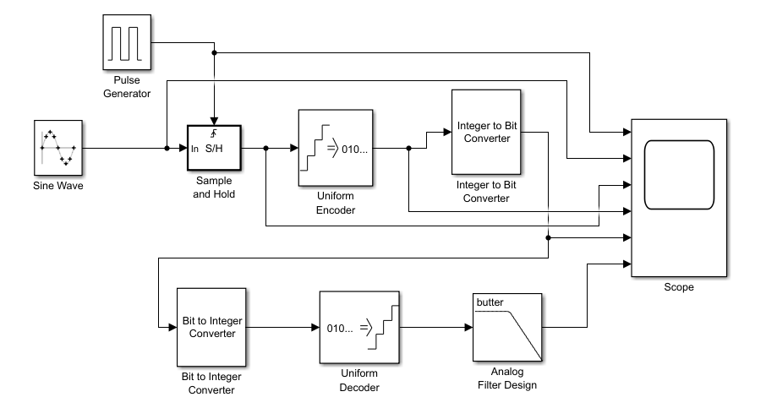

SINE SIGNAL: PULSE SIGNAL:
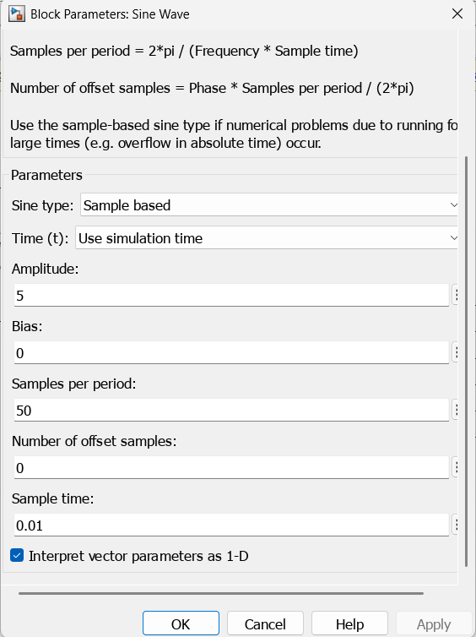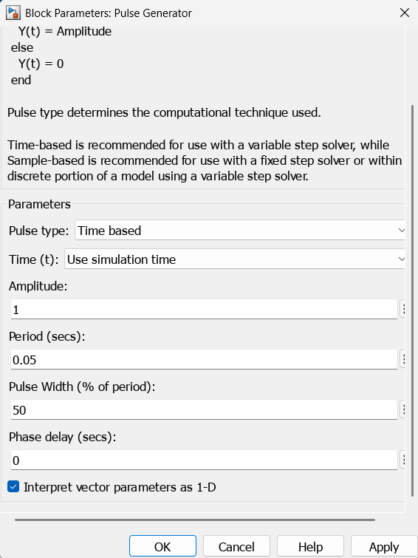

SAMPLE & HOLD: UNIFORM ENCODER:
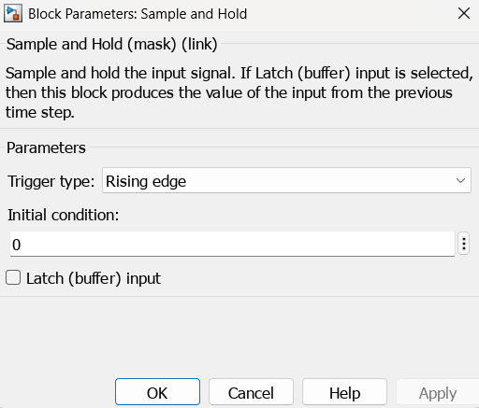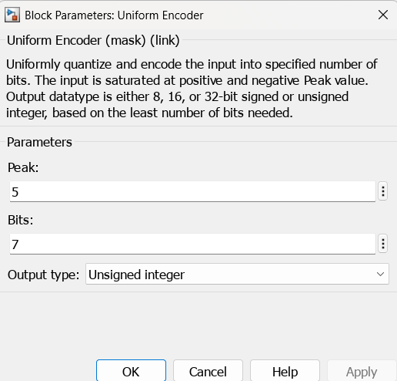
INTEGER TO BIT CONVE.: BIT TO INTEGER CONVE.:
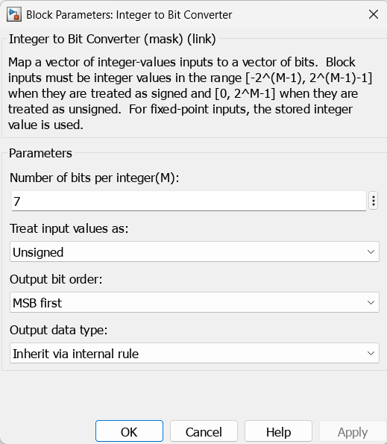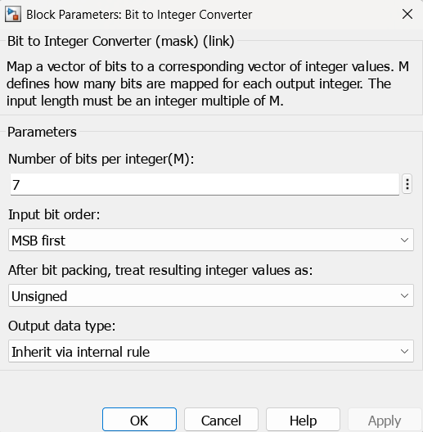

UNIFORM DECODER: ANALOG FILTER DESIGN:
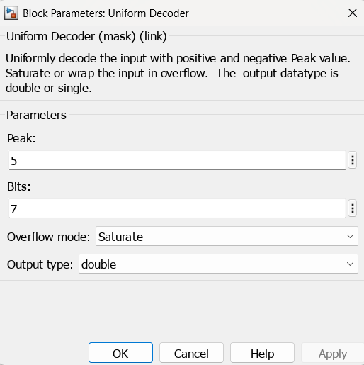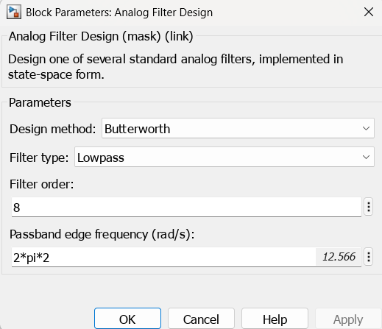
OUTPUT WAVEFORM:

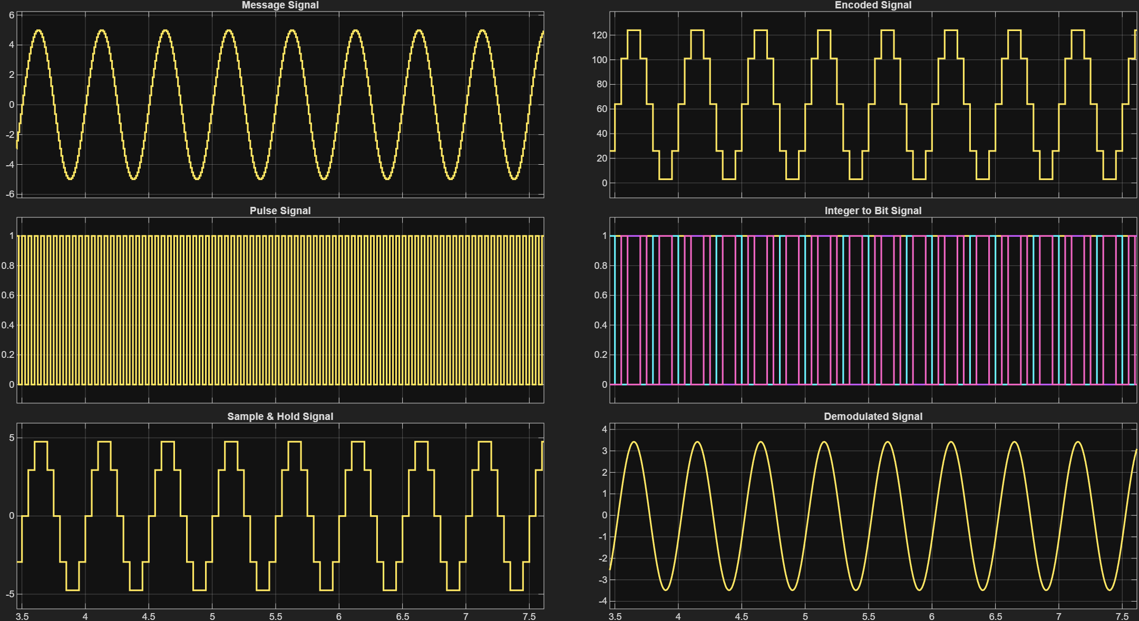
MATLAB CODE:
clc;
close all;
clear all;
n = input('Enter n value for n-bit PCM system :'); % enter 8;
samples = input('Enter number of samples in a period : '); % enter 100

%----------------Sampling Operation-----------------
Am = 8; % message amplitude
x = 0:(2*pi/samples):4*pi;
s = Am*sin(x);
subplot(3,1,1);
plot(s,'r');
grid on;
title('Analog Signal');
ylabel('Amplitude--->');
xlabel('Time--->');
subplot(3,1,2);
stem(s,'g');
grid on;
title('Sampled Signal');
ylabel('Amplitude--->');
xlabel('Time--->');

%----------------Quantization process----------------
M = 2^n; % no. of levels
vmax = Am;
vmin = -vmax;
S = (vmax-vmin)/M;
part = vmin+S:S:vmax-S; % defining the levels
code = vmin+(S/2):S:vmax-(S/2); % defining quantized values in respective levels
[ind,q] = quantiz(s, part, code); % ind contain index number, q contain quantized values
subplot(3,1,3);
stem(q,'b');
grid on;
title('Quantized Signal');
ylabel('Amplitude--->');
xlabel('Time--->');

%----------------Encoding Process----------------
figure
code1 = de2bi(ind, 'left-msb'); % Convert the decimal to binary (MSB is left-most bit)
k = 1;
l1 = length(ind);
% PARALLEL TO SERIAL CONVERTOR
for i = 1:1:l1
for j = 1:n
coded(k) = code1(i,j); % convert code matrix to a coded row vector
k = k+1;
end
end
subplot(2,1,1);
stairs(coded,'m'); grid on;
title('Encoded Signal');
ylabel('Amplitude');
xlabel('Time');
axis([0 50 -0.5 1.5]);

%----------------Demodulation of PCM signal----------------
qunt = reshape(coded, n, length(coded)/n);
index = bi2de(qunt', 'left-msb'); % Get back the index in decimal form
q = vmin+(S/2) + S*index; % get back Quantized values
subplot(2,1,2);
plot(q,'c');
grid on;
title('Demodulated Signal');
ylabel('Amplitude --->');
xlabel('Time--->');

OUTPUT WAVEFORM:

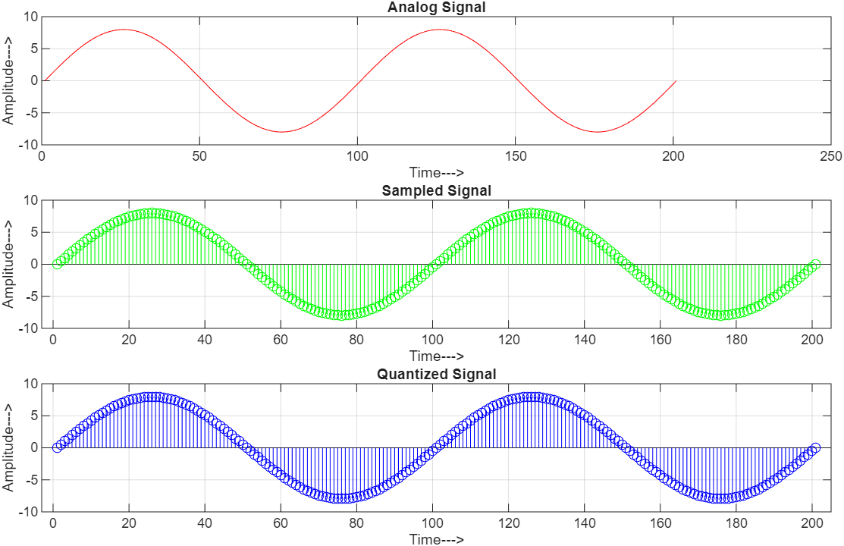

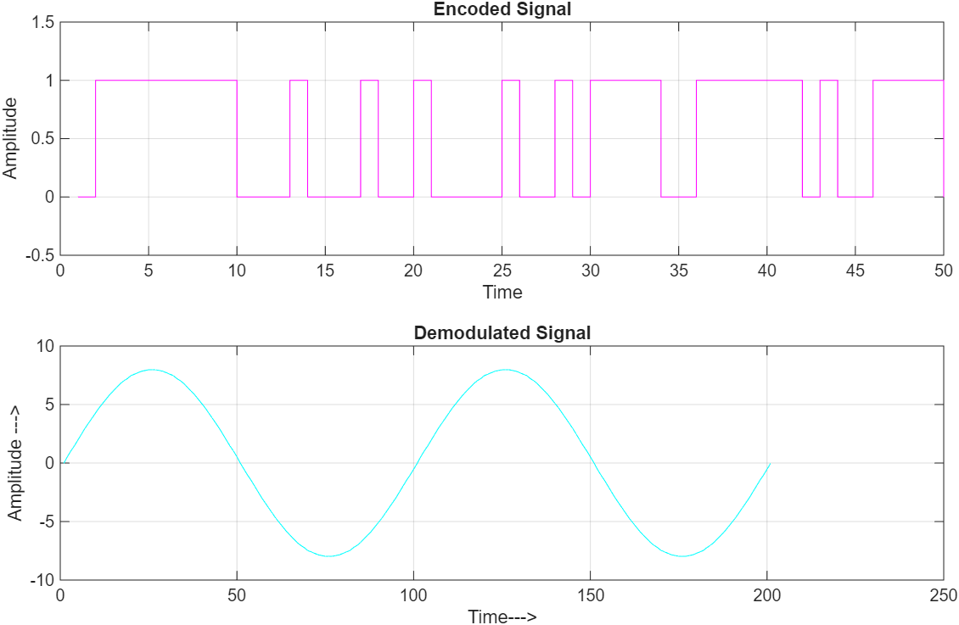

EXPERIMENT – 03

PULSE CODE MODULATION USING NRZ ENCODING

Aim:
To study the operation of Pulse Code Modulation (PCM) using NRZ line encoding.

Theory:
Pulse Code Modulation (PCM) is a digital technique in which an analog signal is converted into a stream of binary digits for reliable transmission. The process starts with sampling, where the analog signal x(t) is measured at equal time intervals. According to the Nyquist sampling theorem, the sampling frequency must satisfy
Fs >= 2Fm
where Fs​ is the sampling frequency and Fm​ is the highest frequency component of the signal. The sampled values are then subjected to quantization, where each sample is approximated to the nearest discrete amplitude level. If the number of quantization levels is L, then the quantization step size is
Δ = (Vmax−Vmin)​/L​
where Vmax and Vmin​ are the maximum and minimum amplitudes of the input signal. Each quantized level is then represented by a binary codeword of length
n = log₂L
bits. The resulting binary sequence is transmitted using a line coding scheme, such as NRZ (Non-Return-to-Zero) encoding, where binary '1' and '0' are represented by distinct constant voltage levels. This produces the PCM modulated waveform.
MATLAB CODE:
clc; clear; close all;

%% Parameters

T = 1; % duration (s)
fm = 5; % message frequency (Hz)
fs = 100; % sampling frequency
L = 32; % quantization levels
sps = 400; % samples per bit in NRZ

%% Step 1: Original Analog Signal

t = 0:0.001:T;
x = sin(2*pi*fm*t);
figure;
subplot(5,1,1);
plot(t, x, 'b', 'LineWidth', 1.5);
title('Original Analog Signal');
xlabel('Time (s)'); ylabel('Amplitude');
grid on; axis tight;

%% Step 2: Sampling

ts = 1/fs;
n = 0:ts:T;
x_s = sin(2*pi*fm*n);
subplot(5,1,2);
stem(n, x_s, 'r','filled','LineWidth',1.0);
title(['Sampled Signal (fs = ' num2str(fs) ' Hz)']);
xlabel('Time (s)'); ylabel('Amplitude');
grid on; axis tight;

%% Step 3: Uniform Quantization

n_bits = log2(L);
xmin = min(x_s); xmax = max(x_s);
Delta = (xmax - xmin)/(L-1);
q_idx = round((x_s - xmin)/Delta);
q_idx = min(max(q_idx,0), L-1);
x_q = xmin + q_idx*Delta;
subplot(5,1,3);
stairs(n, x_q, 'k','LineWidth',1.2);
title(['Quantized Signal (L = ' num2str(L) ' levels)']);
xlabel('Time (s)'); ylabel('Amplitude');
grid on; axis tight;

%% Step 4: PCM Encoding with NRZ

bin_str = dec2bin(q_idx, n_bits);
tx_bits = reshape(bin_str.'-'0', 1, []);
nrz_signal = repelem(tx_bits, sps);
Tb = 1/(fs*n_bits);
dt = Tb/sps;
t_nrz = (0:length(nrz_signal)-1)*dt;
subplot(5,1,4);
plot(t_nrz, nrz_signal, 'LineWidth',1.2,'Color',[0 0.6 1]);
title('PCM with NRZ Encoding (Tx)');
xlabel('Time (s)'); ylabel('Level');
grid on; axis tight;

%% Step 5: Reconstructed Signal (direct from quantized values)

x_hat = x_q; % reconstruction = quantized version
subplot(5,1,5);
stairs(n, x_hat, 'm','LineWidth',1.2);
title('Reconstructed Signal at Receiver');
xlabel('Time (s)'); ylabel('Amplitude');
grid on; axis tight;

OUTPUT WAVEFORM:

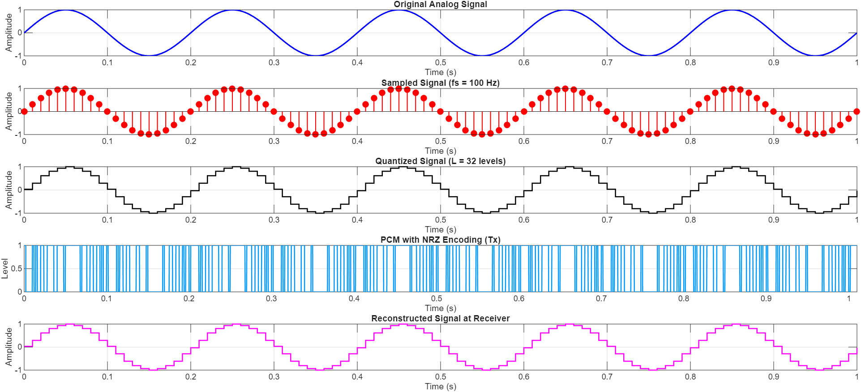

EXPERIMENT – 04

AMPLITUDE SHIFT KEY

Aim:
To study the operation of Amplitude Shift Key (ASK).

Theory:
Amplitude Shift Keying (ASK) is one of the fundamental digital modulation schemes where the amplitude of a high-frequency carrier signal is varied according to the digital input data, while the frequency and phase of the carrier remain constant. In simple terms, the carrier is present with a fixed amplitude to represent a binary ‘1’ and absent or reduced in amplitude to represent a binary ‘0’. This makes ASK equivalent to On-Off Keying (OOK) in its simplest form. ASK is easy to design and implement, which makes it useful in applications where simplicity and low cost are important.
During ASK modulation, the binary input sequence is multiplied with the carrier wave. If the bit is ‘1’, the carrier of amplitude Ac​ is transmitted; if the bit is ‘0’, either no carrier or a reduced amplitude carrier is transmitted. The modulated signal can be mathematically expressed as:
s(t) = b(t) . A_{c} cos(2πf_{c}t)
where b(t) is the binary sequence, A_{c}​ is the carrier amplitude, and f_{c}​ is the carrier frequency. The process produces a signal whose amplitude changes according to the data bits, but frequency and phase remain unchanged.
Although ASK modulation and demodulation circuits are simple to implement, the technique suffers from poor noise immunity because noise primarily affects the amplitude of a signal. Therefore, ASK is not suitable for long-distance or high-speed communication in noisy channels. However, it is widely used in short-range, low-bandwidth applications.
Procedure:
- Open Simulink Blank Model and add various blocks including: Sine Wave, Pulse Generator, Product, Signum and Scope.
- Make changes in properties of various blocks as shown in the images.
- Save the model and click on Run to obtain the plot.

Block Diagram:

Blocks Required:
- Sine Wave Block
- Pulse Generator Block
- Product Block
- Signum Block
- Scope Block

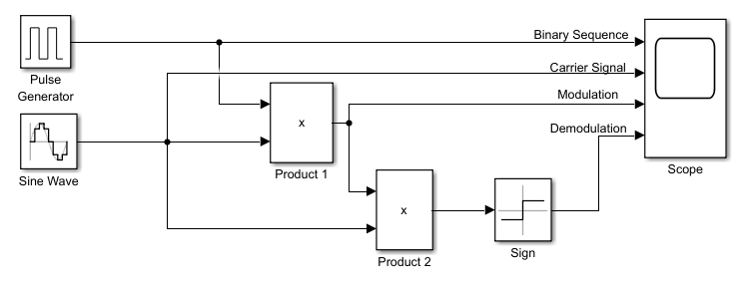

SINE SIGNAL:
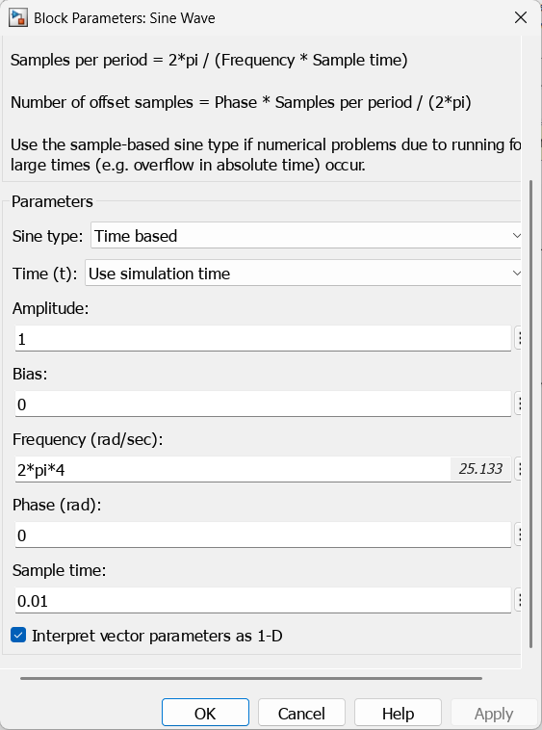
PULSE SIGNAL:
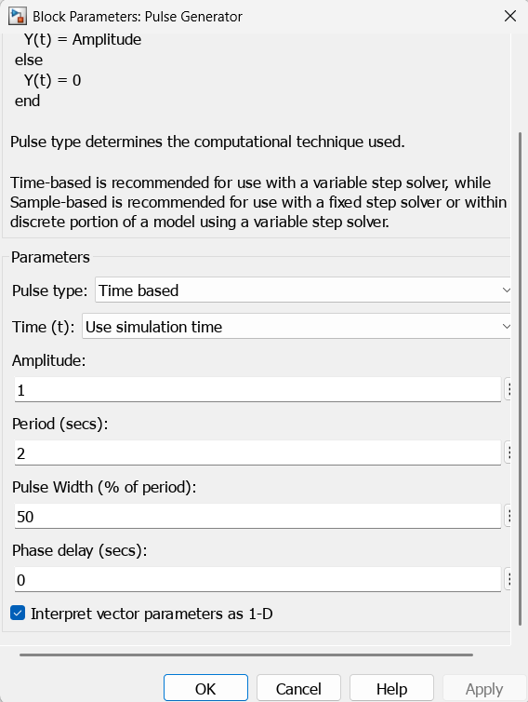

OUTPUT WAVEFORM:

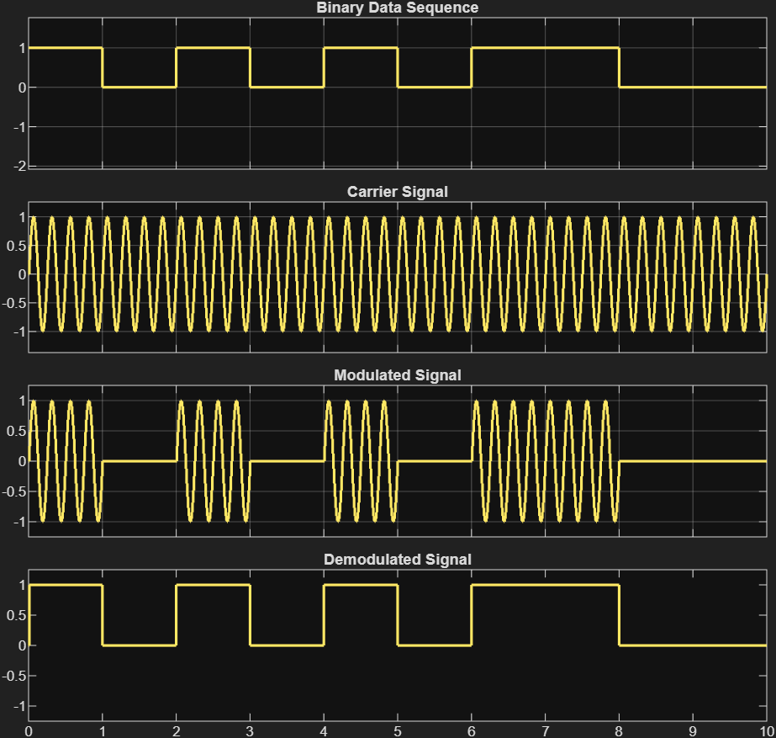

MATLAB CODE:
clc;
clear all;
close all;

% ---------------- Input Binary Data ----------------
data = [1 0 1 1 0 0 1 0]; % binary sequence
N = length(data); % number of bits
Tb = 1; % bit duration
Fs = 1000; % sampling frequency
t = 0:1/Fs:Tb-1/Fs; % time for one bit

% Carrier parameters
Ac = 5; % carrier amplitude
Fc = 10; % carrier frequency
c = Ac*cos(2*pi*Fc*t); % carrier signal for 1 bit

% ---------------- ASK Modulation ----------------
ask_signal = [];
for i = 1:N
if data(i) == 1
ask_signal = [ask_signal c]; % transmit carrier for bit '1'
else
ask_signal = [ask_signal zeros(1,length(t))]; % zero for bit '0'
end
end

% Time axis for whole signal
tt = 0:1/Fs:N*Tb-1/Fs;

% ---------------- Plot Signals ----------------
figure;

subplot(3,1,1);
stairs(0:N-1,data,'r','LineWidth',2); % red color
ylim([-0.5 1.5]); grid on;
title('Input Digital Data','Color','r');
xlabel('Bit Index'); ylabel('Amplitude');

subplot(3,1,2);
plot(tt,ask_signal,'b','LineWidth',1.5); % blue color
grid on;
title('ASK Modulated Signal','Color','b');
xlabel('Time'); ylabel('Amplitude');

% ---------------- ASK Demodulation ----------------
demod = [];
for i = 1:N
y = ask_signal((i-1)*length(t)+1:i*length(t)).*c; % multiply with carrier
z = trapz(t,y); % integration (approx)
if z > 0.5 % threshold detection
demod = [demod 1];
else
demod = [demod 0];
end
end

subplot(3,1,3);
stairs(0:N-1,demod,'m','LineWidth',2); % green color
ylim([-0.5 1.5]); grid on;
title('Demodulated Data','Color','m');
xlabel('Bit Index'); ylabel('Amplitude');

OUTPUT WAVEFORM:

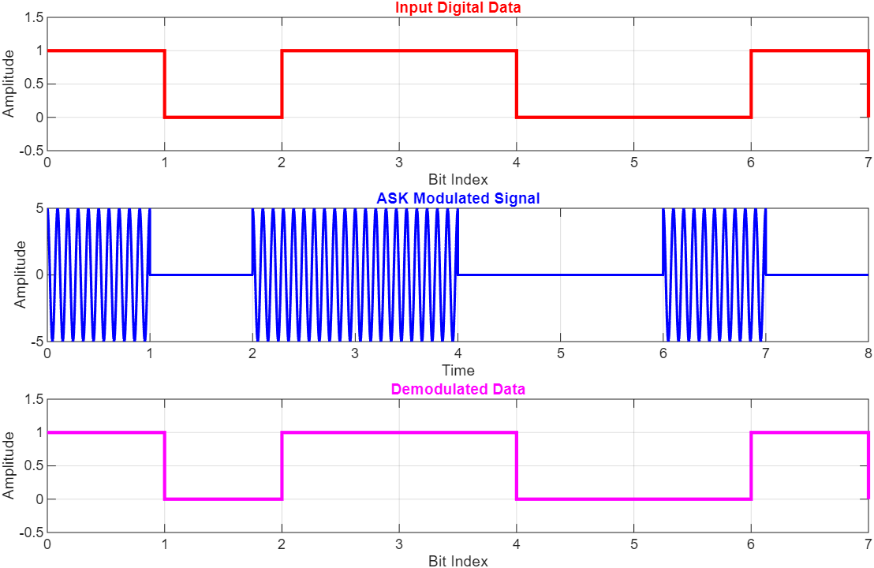

EXPERIMENT – 05

FREQUENCY SHIFT KEY

Aim:
To study the operation of Frequency Shift Key (FSK).

Theory:
Frequency Shift Keying (FSK) is a digital modulation technique in which the frequency of a carrier signal is varied according to the input digital data, while the amplitude and phase remain constant. In its simplest form, binary FSK (BFSK) uses two distinct carrier frequencies: one frequency represents binary ‘1’ and another represents binary ‘0’. This frequency-based separation makes FSK more robust against noise compared to ASK, since noise affects amplitude more easily than frequency.
In FSK modulation, the digital input sequence controls the frequency of the carrier wave. When the input bit is ‘1’, the modulator generates a carrier with frequency f₁​; when the input bit is ‘0’, it generates a carrier with frequency f₀​. The mathematical representation of a binary FSK signal can be given as:
s(t) = A_{c} cos(2πf₁t), for bit 1
= A_{c} cos(2πf₀t), for bit 0
where A_{c} is the carrier amplitude and f₀ , f₁​ are the two distinct frequencies used to represent binary symbols.
Demodulation of FSK can be achieved by using coherent or non-coherent detection methods. In coherent detection, the receiver uses two correlators or bandpass filters tuned to f₀ and f₁​. The stronger output indicates the transmitted bit. Coherent detection provides better accuracy, while non-coherent detection is simpler but more prone to errors.

Procedure:
- Open Simulink Blank Model and add various blocks including: Sine Wave, Pulse Generator, Switch and Scope.
- Make changes in properties of various blocks as shown in the images.
- Save the model and click on Run to obtain the plot.

Block Diagram:

Blocks Required:
- Sine Wave Block
- Pulse Generator
- Switch Block
- Scope Block

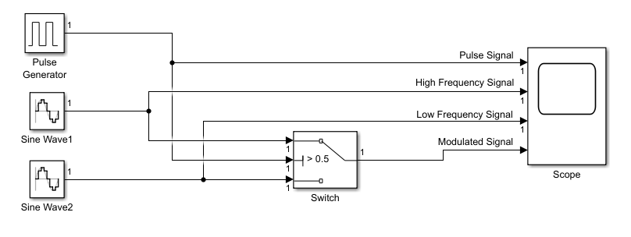

SINE SIGNAL 1: SINE SIGNAL 2:
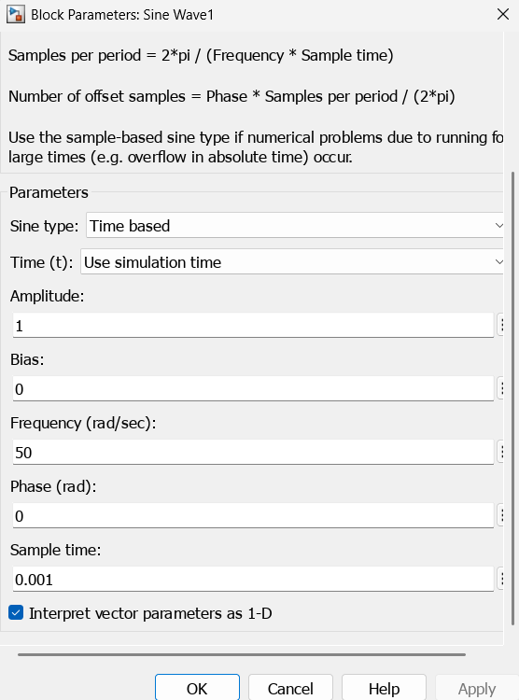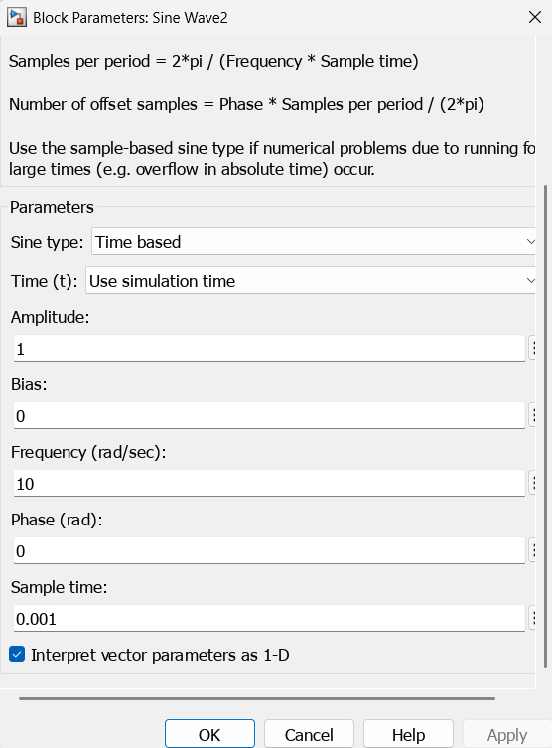

PULSE SIGNAL: SWITCH:
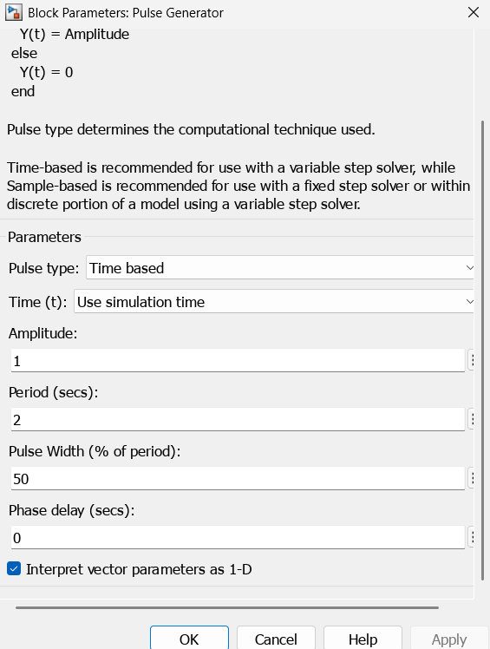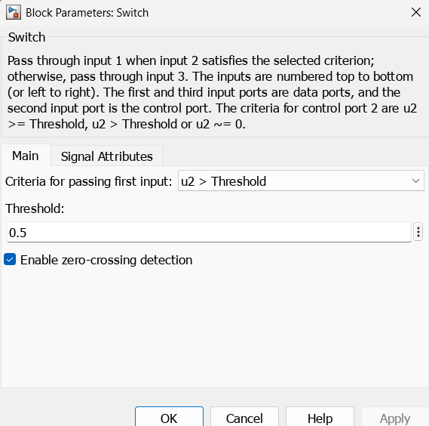

OUTPUT WAVEFORM:

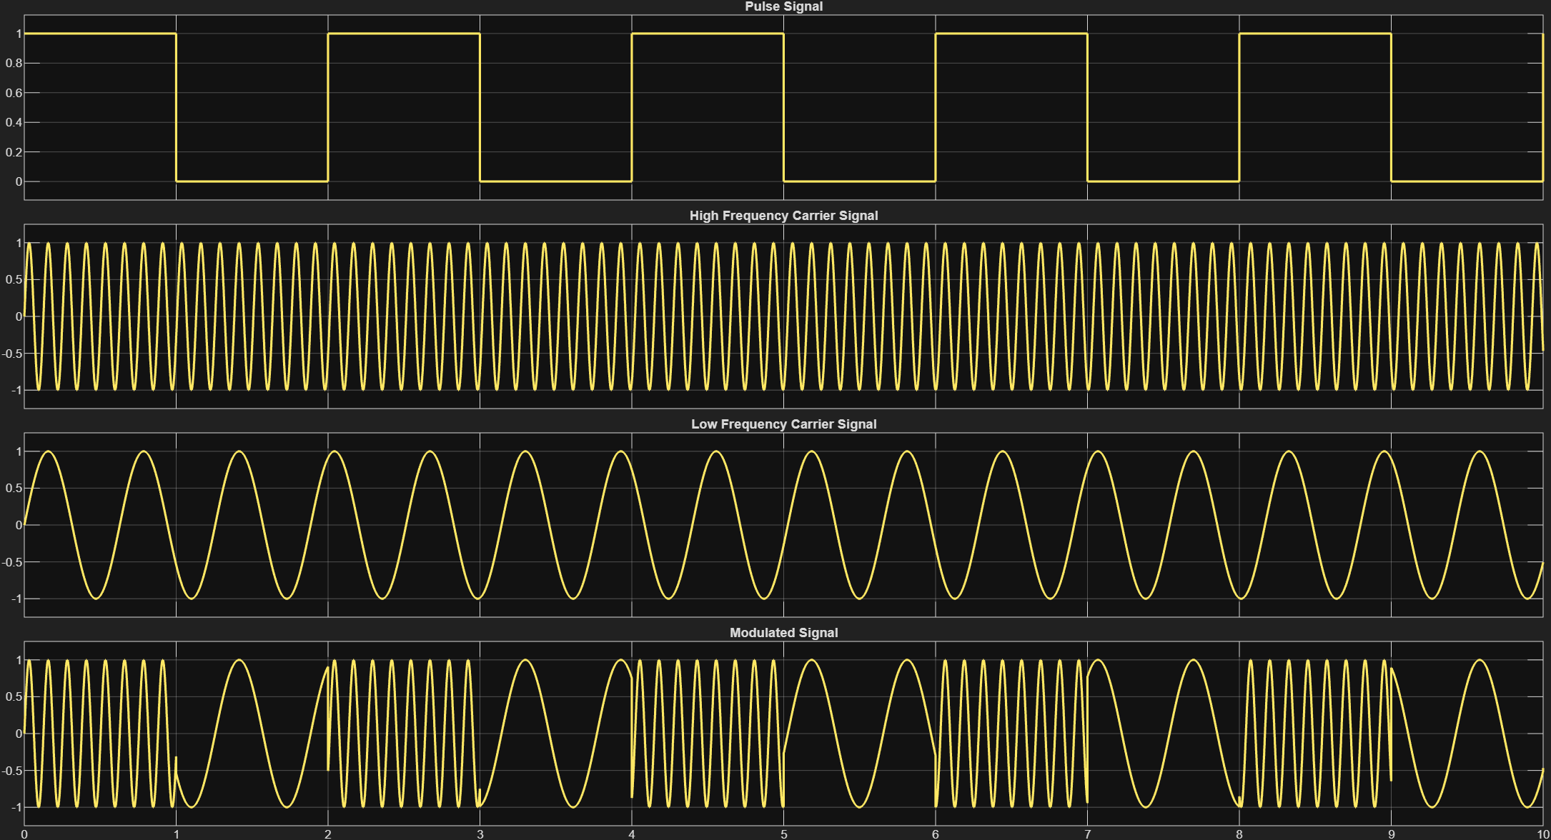

MATLAB CODE:
clc; clear; close all;

%% Parameters
N = 8; % Number of bits
Rb = 1; % Bit rate (bits/sec)
Tb = 1/Rb; % Bit duration
fs = 1000; % Sampling frequency
t = 0:1/fs:N*Tb-1/fs; % Time vector

% Carrier frequencies
f0 = 5; % Frequency for bit '0'
f1 = 10; % Frequency for bit '1'

%% Generate random binary data
data = randi([0 1],1,N);

%% FSK Modulation
x = []; % FSK modulated signal
for i=1:N
if data(i)==1
x = [x cos(2*pi*f1*(0:1/fs:Tb-1/fs))]; % bit 1 -> f1
else
x = [x cos(2*pi*f0*(0:1/fs:Tb-1/fs))]; % bit 0 -> f0
end
end

%% Plot Modulated Signal
figure;
subplot(3,1,1);
stairs(data,'LineWidth',2); grid on;
title('Input Digital Data'); xlabel('Bit Index'); ylabel('Amplitude');
ylim([-0.5 1.5]);

subplot(3,1,2);
plot(t,x,'LineWidth',1.2); grid on;
title('FSK Modulated Signal'); xlabel('Time (s)'); ylabel('Amplitude');

%% FSK Demodulation (Non-coherent using correlation)
demod_bits = [];
for i=1:N
% Extract one bit duration
t_bit = (i-1)*Tb : 1/fs : i*Tb-1/fs;
y_bit = x((i-1)*Tb*fs+1 : i*Tb*fs);

% Correlate with both carriers
c0 = cos(2*pi*f0*t_bit);
c1 = cos(2*pi*f1*t_bit);
corr0 = sum(y_bit .* c0);
corr1 = sum(y_bit .* c1);

% Decision
if corr1 > corr0
demod_bits = [demod_bits 1];
else
demod_bits = [demod_bits 0];
end
end

subplot(3,1,3);
stairs(demod_bits,'r','LineWidth',2); grid on;
title('Demodulated Data'); xlabel('Bit Index'); ylabel('Amplitude');
ylim([-0.5 1.5]);

OUTPUT WAVEFORM:

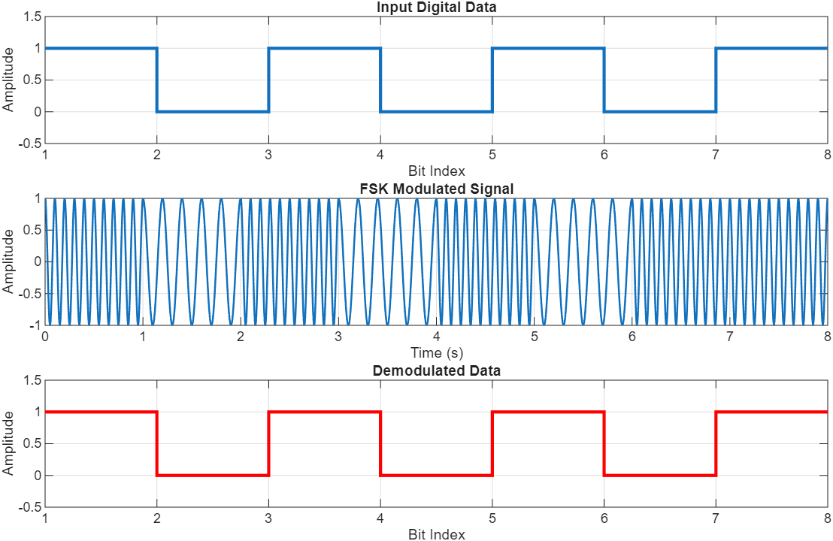

EXPERIMENT – 06

PHASE SHIFT KEY

Aim:
To study the operation of Phase Shift Key (PSK).

Theory:
Phase Shift Keying (PSK) is a digital modulation technique in which the phase of a carrier signal is changed according to the digital input data, while the amplitude and frequency remain constant. By altering the phase of the carrier, binary information can be transmitted effectively. The general form of a PSK signal is:
s(t) = sqrt (2E_{b}/T_{b}) (cos(2πf_{c}t + ϕ_{i}))
where E_{b}​ is the energy per bit, T_{b} is the bit duration, f_{c} is the carrier frequency and ϕ_{i} is the phase depending on the transmitted symbol.
PSK is mainly of two types:
- Binary Phase Shift Keying (BPSK):
Also known as 2-phase PSK. In this method, the phase of the carrier takes two values—0° for binary '1' and 180° for binary '0'.
- Quadrature Phase Shift Keying (QPSK):
In this method, the carrier takes four different phase values—0°, 90°, 180°, and 270°. Each symbol represents two bits, thus improving bandwidth efficiency compared to BPSK.
Demodulation of PSK is usually performed using coherent detection. The receiver compares the phase of the incoming signal with a reference carrier to decide the transmitted bit or symbol. In BPSK, 0° is detected as '1' and 180° as '0’, while in QPSK, four phases are mapped to their respective two-bit combinations.

Procedure:
- Open Simulink Blank Model and add various blocks including: Sine Wave, Pulse Generator, Constant, Product, Switch and Scope.
- Make changes in properties of various blocks as shown in the images.
- Save the model and click on Run to obtain the plot.

Block Diagram:

Blocks Required:
- Sine Wave Block
- Pulse Generator
- Constant Block
- Product Block
- Switch Block
- Scope Block

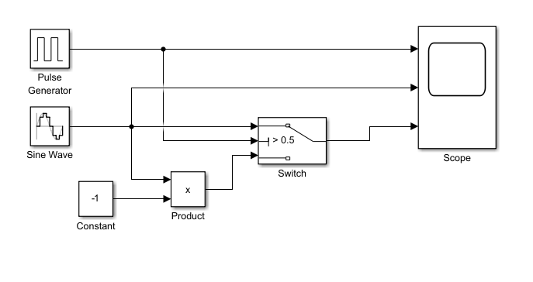

SINE SIGNAL: PULSE SIGNAL:
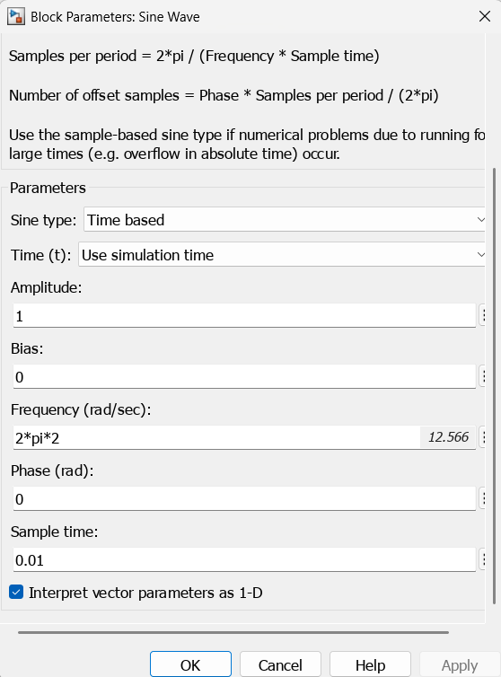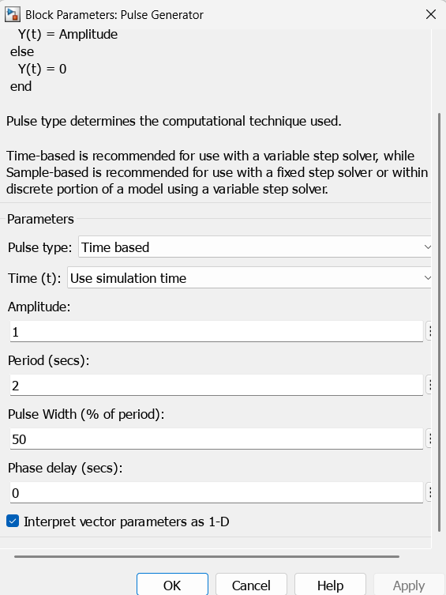

CONSTANT: SWITCH:
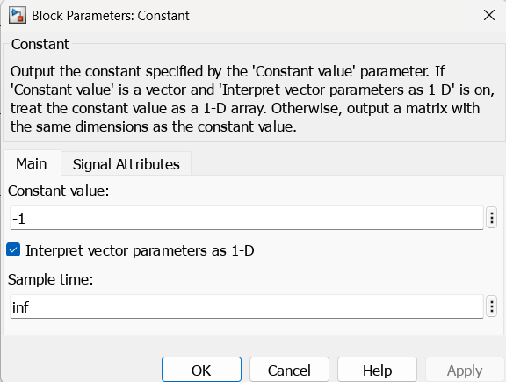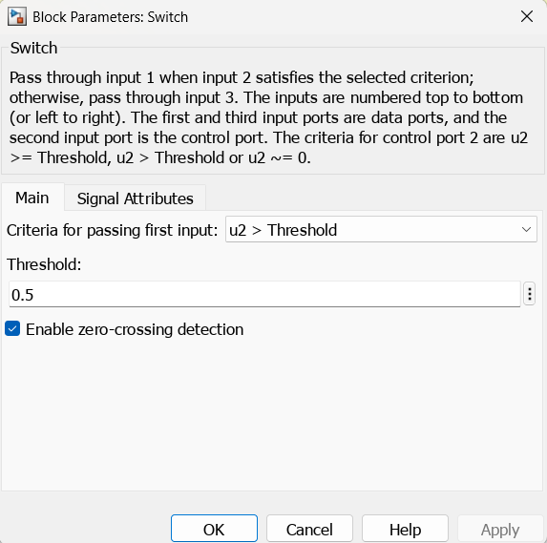
OUTPUT WAVEFORM:

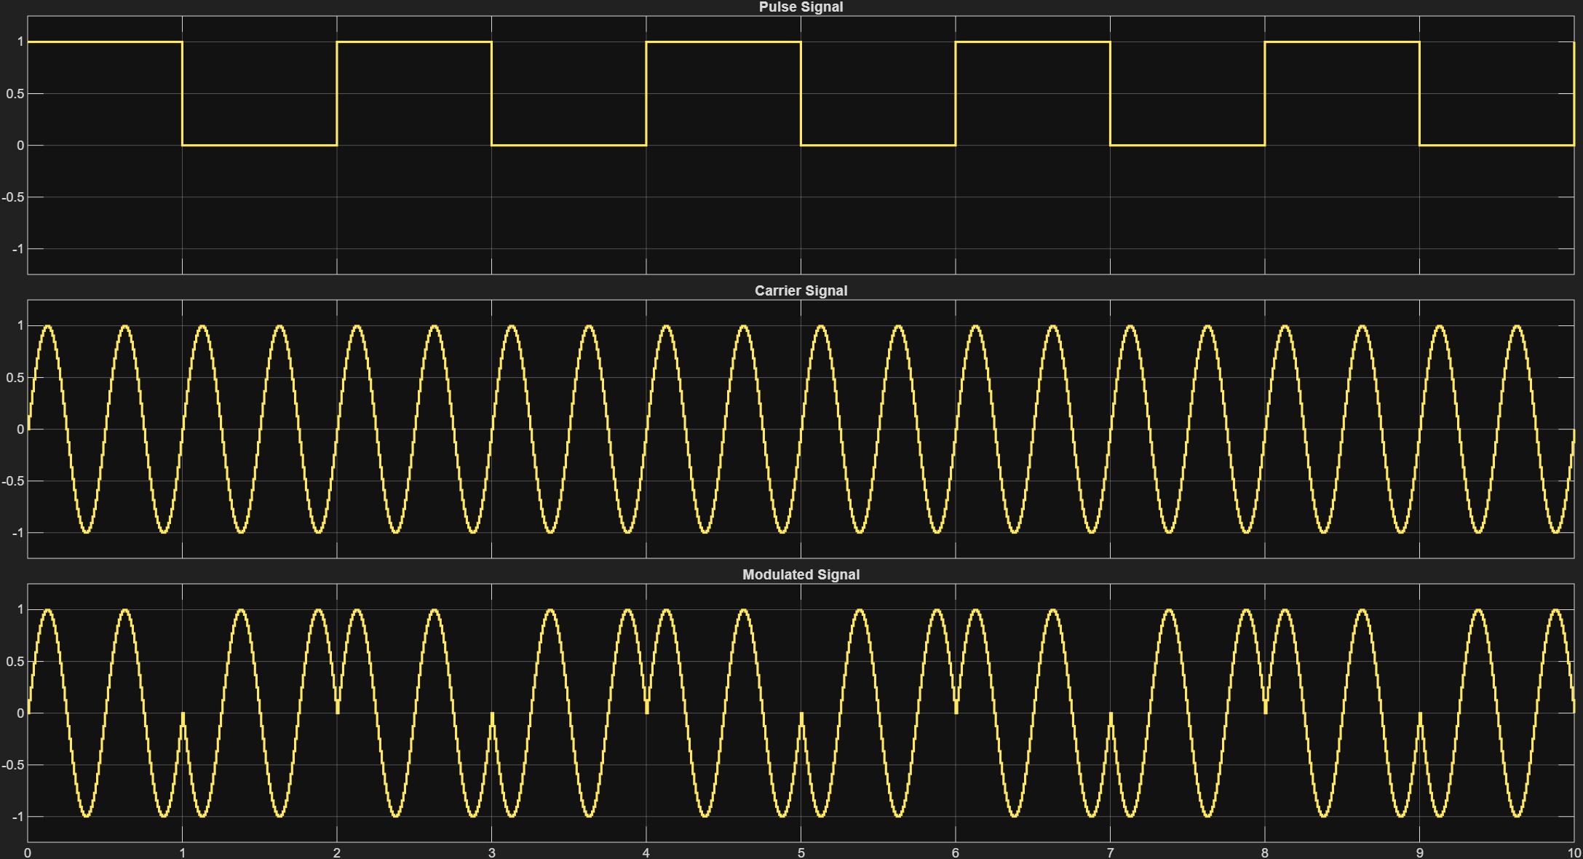

MATLAB CODE:
clc;
clear all;
close all;

% Generate random binary input
N = 10; % Number of bits
data = randi([0 1],1,N); % Random 0/1 sequence

% Parameters
Tb = 1; % Bit duration
Fs = 100; % Sampling frequency
t = 0:1/Fs:Tb-1/Fs; % Time for one bit
fc = 2; % Carrier frequency

% -------- Generate NRZ Pulse Input --------
nrz_pulse = [];
for i=1:N
if data(i) == 1
nrz_pulse = [nrz_pulse ones(1,length(t))]; % Pulse at 1
else
nrz_pulse = [nrz_pulse zeros(1,length(t))]; % Pulse at 0
end
end

% Time vector for full signal
t_total = 0:1/Fs:N*Tb-1/Fs;

% -------- PSK Modulation --------
psk_signal = [];
for i=1:N
if data(i) == 1
psk_signal = [psk_signal cos(2*pi*fc*t)]; % bit = 1, phase = 0
else
psk_signal = [psk_signal cos(2*pi*fc*t + pi)]; % bit = 0, phase = 180
end
end

% Plot Input Pulse Data
figure;
subplot(3,1,1);
plot(t_total,nrz_pulse,'r','LineWidth',1.5);
title('Input Binary Data (NRZ Pulse)');
xlabel('Time'); ylabel('Amplitude'); grid on;
axis([0 N -0.5 1.5]);

% Plot PSK Modulated Signal
subplot(3,1,2);
plot(t_total,psk_signal,'b','LineWidth',1.2);
title('PSK Modulated Signal');
xlabel('Time'); ylabel('Amplitude'); grid on;

% -------- PSK Demodulation --------
demod_data = [];
for i=1:N
% Extract one bit duration
r = psk_signal((i-1)*Fs+1 : i*Fs);
% Correlate with reference carrier
c = cos(2*pi*fc*t);
decision = sum(r.*c);
if decision > 0
demod_data = [demod_data 1];
else
demod_data = [demod_data 0];
end
end

% -------- Reconstruct NRZ Demodulated Signal --------
nrz_demod = [];
for i=1:N
if demod_data(i) == 1
nrz_demod = [nrz_demod ones(1,length(t))];
else
nrz_demod = [nrz_demod zeros(1,length(t))];
end
end

% Plot Demodulated Data (NRZ Pulse)
subplot(3,1,3);
plot(t_total,nrz_demod,'g','LineWidth',1.5);
title('Demodulated Data (NRZ Pulse)');
xlabel('Time'); ylabel('Amplitude'); grid on;
axis([0 N -0.5 1.5]);

OUTPUT WAVEFORM:

